Survival Prediction Results Page (Doctor’s view)

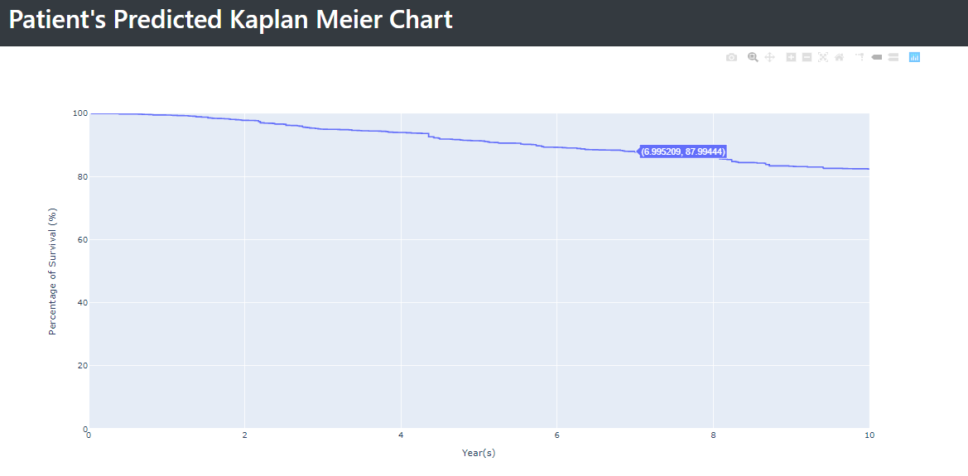

The patient’s predicted survival rate is presented in a Kaplan Meier survival chart, where the x-axis is the years from the diagnosis date and y-axis is the survival rate. The results show the survival rate from the diagnosed date to 10 years after the diagnosed date.

Survival Prediction Results Page (Patient’s view)

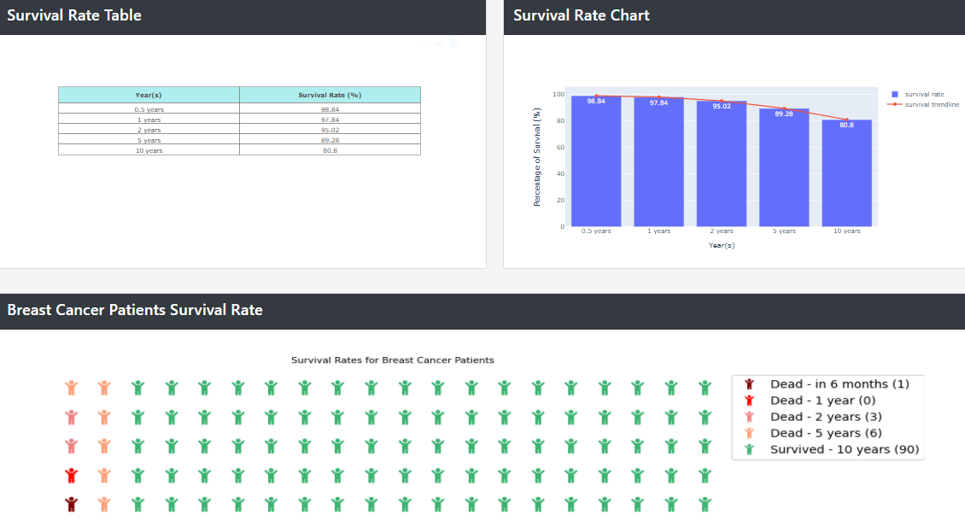

The patient’s predicted survival rate is presented in a table form, in a bar with line chart, as well as in a waffle chart where different red shades stickman represents the number of deaths at each time frame and stickman in green colours represent the overall survival after 10 years.

Like the Kaplan Meier chart in the Doctor’s view tab, the results show the survival rate from the diagnosed date to 10 years but in specific time intervals: 6 months after, 1 year after, 2 years after, 5 years after and 10 years after.

Cost Prediction Results Page

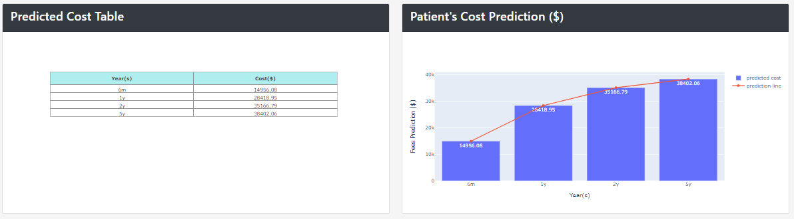

The patient’s cost prediction rate is presented in a table form, in a bar with line chart. The results of the charts show the predicted cost from the diagnosed date to 5 years after. The amount predicted to be the cost of the patient is broken down in the time frame: 6 months after, 1 year after, 2 years after, 5 years after.

Dashboard (Bills)

* Per Patient Expenditure Scatter Plot

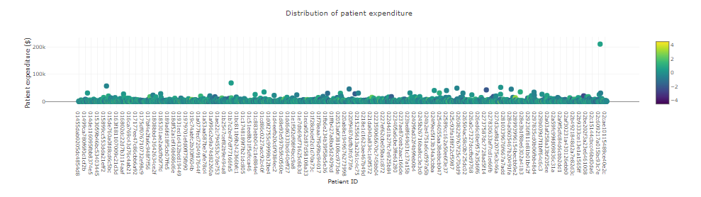

This chart displays the sum of all transactions for each patient. The user can use the slider in the filter panel to select a sample size of his or her choice to have a clearer view of the distribution.

* Pie Chart: Gross Expenditure By Category



This pie chart shows total gross expenditure for each category. User can filter out categories of his/her choice for this chart.

* Bar Chart: Average expenditure By category

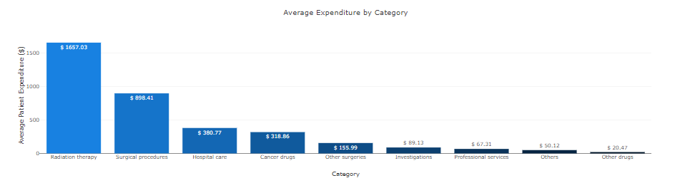

Similar to the chart mentioned directly above, this chart shows the average expenditure for each category. This chart has no filters.

Dashboard (Clinical)

* Age Histogram charts

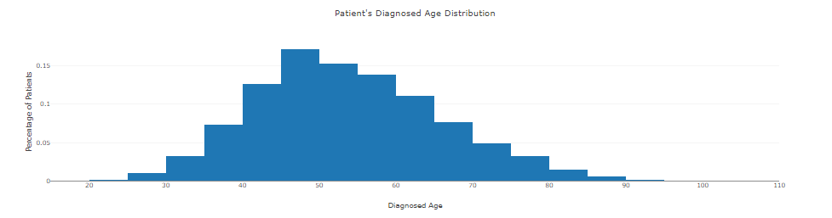  
  
Shows the age distribution of the patients based on the cancer features filtered and demographics of the patients selected.

* Alive Vs Dead status charts

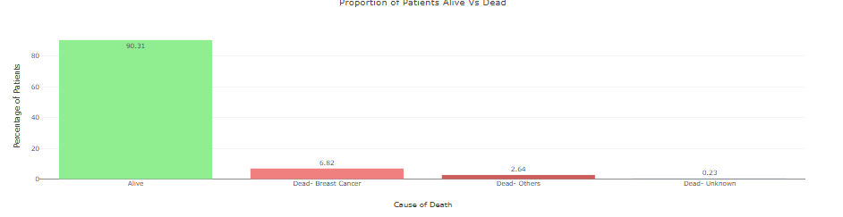  
  
Shows patients chances of being alive or dead due to breast cancer, unrelated causes or unknown causes based on the data of other cancer patients depending of the features filtered and demographics of the patients selected.

* ER Hormone Vs PR Hormone’s correlation status chart

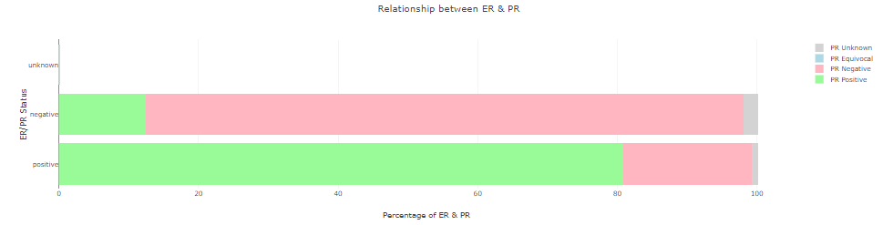  
  
Shows the chances of a patient being Positive for both ER and PR, negative for both ER and PR based on the data of other cancer patients depending of the features filtered and demographics of the patients selected.

* Descriptive Kaplan Meier chart

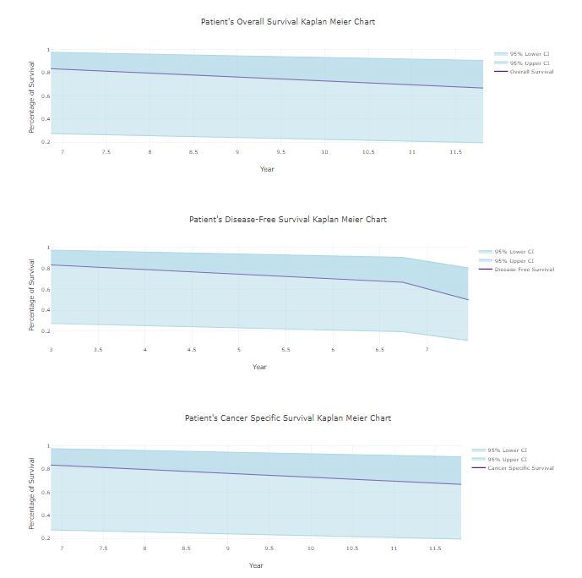  
  
Shows results like the predicted Kaplan Meier Chart of the survival model’s predicted page (doctor’s view). The data shown is based on past data of other cancer patients, depending of the features filtered and demographics of the patients selected.  
  
The Kaplan Meier chart also shows patient’s predicted survival rate where the x-axis is the years from the diagnosis date and y-axis is the survival rate for Disease Free Survival, Overall survival and cancer specific survival.